Panathlon at Home Challenge
Garden Games
Thank you for taking part in the ‘Panathlon at Home’ challenges. There are 9 garden games with numerous variations in this pack together with a scoring template.
Use these games as a guide. You may adapt the equipment and use whatever objects you have at home. You could change the size of games to fit your space. Challenge yourself, play for your personal best and be determined to improve on your own records.

Adaptations
Visually impaired players: A helper can clap to aid for direction to a target or assist with changes in direction.
Wheelchair users: Ramps can be used to help propel objects. If you don’t have a ramp, use a long piece of cardboard, change the distances or place the equipment off ground level, for example on a table, instead.

Let us know how well you’ve done via @panathlon on social media and via #PanathlonGardenGames

To receive a certificate please email events@panathlon.com with your score sheet as a record.

Shooting Range
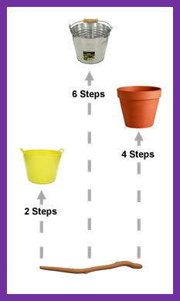
Video Link - https://youtu.be/WdECq1NgDMM
Equipment:
- 3 x Balls (rolled up socks, balls of tin foil)
- 3 x Buckets (basket, flexi tub, cardboard box, plant pot)
- Stick (rope, string, use a defined line)
- Kitchen Timer (stopwatch)

Set-up: See diagram.

Aim: “Throw the balls into the buckets”
- Throw from behind the stick line. 3 throws per turn.
- Start throwing towards the closest bucket (2 steps away). If unsuccessful continue throwing at that bucket.
- If successful, throw towards the next closest bucket (4 steps away). If successful, with the third and final throw, throw towards the furthest bucket (6 steps away).
- The ball must stay in the bucket to score. Consider weighting the bucket down to prevent it toppling over with a large stone or water etc.
Scoring:
- 1 point per ball thrown into and remaining in the bucket.
- If the ball bounces out of the bucket, no score.
- 1 Bonus Point, if all three buckets are scored in one turn (3 throws).

- Timed: Total points based on one minutes play using 3 balls. Retrieve your own balls. Use a kitchen timer. Once you are successful with the furthest bucket, continue back at the closest bucket again. Get 3 scores in a row at any time, add a bonus point.
- Timed: Total number of points based on two minutes play using only 1 ball. Retrieve your own ball.
- Best Score: How many throws does it take to complete two successful rounds? (6 baskets)

Variations:
- Vary the size of the balls (tennis ball, basketball). Vary the size of the buckets. Increase/decrease the distance from the line to the buckets. Change rules to ‘One bounce and in’. Can you bounce the ball in & out a the bucket? Try different throwing techniques: underarm, overarm
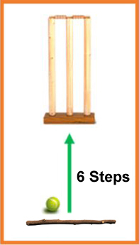
‘Direct Hit’ Variation:
- Additional Equipment: Set of Stumps (3 canes, 3 straight sticks).
- Set up: Push the 3 canes into the ground next to each other like a set of cricket stumps, 6 steps away from a throwing line.
- Aim: “Throw to hit the stumps (canes) with the ball”
- Once you have hit one of the 3 canes remove one of them (any of them). Now aim at the remaining 2 canes.
- Once you have hit one of the 2 canes, remove one of them and now aim for the remaining 1 cane.
- How many throws does it take you to hit the canes 3 times (with 3 canes, 2 canes, then just 1 cane in the ground)?

Messi Football
Video Link - https://youtu.be/I_ZxFt5DmoA
Equipment:
- Football
- Goal (two sticks, canes, buckets, jumpers)
- 2 x Tall Cones (sticks, canes)
- 6 x Plant Pots (pile of leaves, hats)
- Kitchen Timer (stopwatch)
Set-up: See diagram below. Place the 2 tall cones in the goal to create three equal sections.
Aim: “Dribble the ball through two sets of plant pots and then score a goal!”
- From the start line, dribble the ball through the first sets of pots and continue to the right set of pots.
- Once through the second set of pots, shoot to score. You can get as close as you want, before shooting.
- On the next round, continue to the left set of pots - alternate sides for each turn.

Scoring:
- 1 point = Goal scored in the middle section
- 2 points = Goal scored in either of the two outer sections, as below diagram.

- Timed: Total points based on one minute of play. Retrieve your own ball, return to the start line.
- High Score: 8 continuous turns. How many points can you score? (16 points being the highest score possible.)

Variations:
- Alternating striking feet.
- Strike with your non-dominant foot.
- Dribble with your left foot only when playing through the left side. Dribble with your right foot only whilst playing to the right side.
- If with a friend or family member, involve passing. Pass to the player at the start line, then, have a 1-2 return pass after the cones, before shooting.
- Play Basketball. Dribble, then bounce pass or chest pass into the goal.
- Wheelchair users: May hold the ball in hands and throw the ball at the goal.

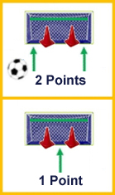
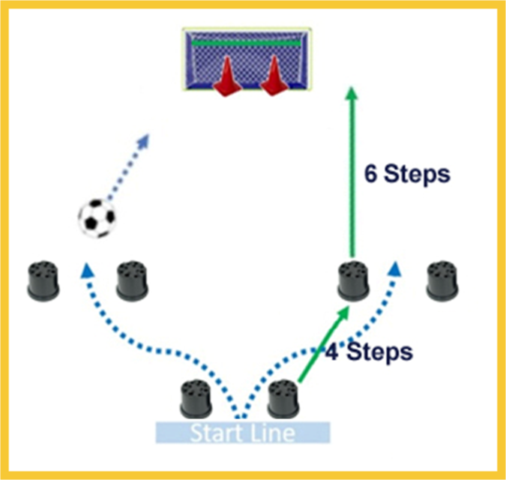

Precision Football

Video Link – To come, in future update of this document
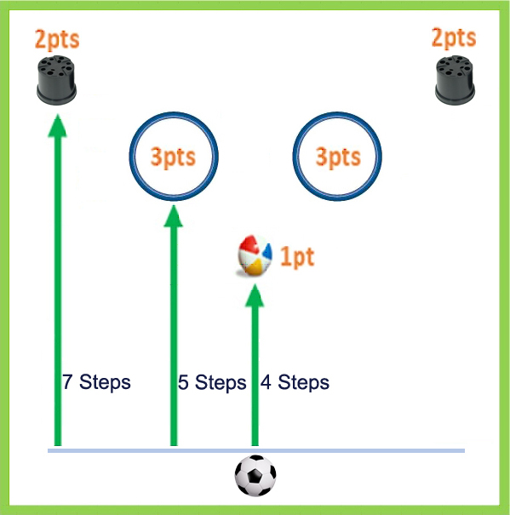
Equipment:
- Football
- Large Ball (Bucket)
- 2 x Empty Plant Pots (plastic bottles)
- 2 x Hoops (Newspaper, cardboard cut outs)
- Kitchen Timer (stopwatch)

Set-up: Set out the five items at three different distances in a “V” shape. See diagram.

Aim: “Kick a football at, and, onto the targets to gain points.”
- 6 kicks per turn.
- Ensure the ball is stationary before each kick.
- Retrieve your ball after each kick and continue.

Scoring:
- 1 point = Large Ball is hit. Replace on its original position each time it is hit.
- 2 points = Plant pot is hit or knocked over. Do not replace for the rest of that turn of 6 kicks.
- 3 points = Football comes to rest in either hoop.

- High Score: Best score from one turn (6 kicks) kicking a stationary ball.
- High Score: Best score from turn (6 kicks) kicking a moving ball. You will need a family member to roll or pass the ball to the player. Allow for 6 good feeds.
- Timed: Best score from 60 seconds of play. Retrieve your own ball. Don’t replace the 2 point plant pots once they have been hit.

Variations:
- Wheelchair users: May hold the ball in hands and throw rather than kick.
- Change the distances of the items.
- Alternate striking feet and/or strike with your non-dominant foot.
- Throw instead of kick – underarm rolls, or football overhead throw-in (ball to bounce in the hoops).
- Add a dribble slalom alongside the target area. Dribble the ball back to the start each time.
- Adapt & play with a tennis ball, or with a ball & hockey stick
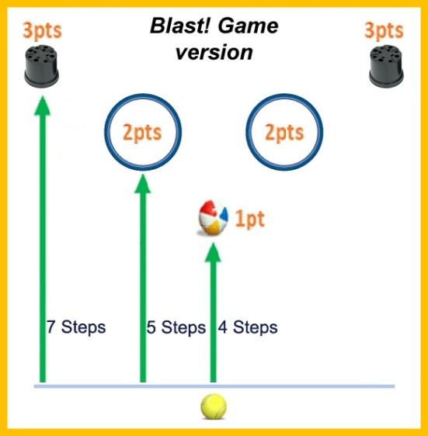
- Blast! Game – Play the same game with a tennis ball.
- Change the points:
  - 1 point = Large Ball is hit. (Same, as above)
  - 2 points = Ball comes to rest in either hoop.
  - 3 points = Plant pot is hit or knocked over.

Through The Gap
Video Link – To come, in future update of this document
Equipment:
- Football
- 6 x Empty Plant Pots (plastic bottles, add water in bottle for weight)
- Tape Measure

Set-up: Use the tape measure to measure gaps between the pots, from 70cm to 30cm. If you don’t want to measure it, just create suitable decreasing gaps between the pots.
Aim: “Kick the football through the narrowing gaps”
- Five kicks per turn.
- At the start of each turn, aim for the largest gap (70cm).
- If you kick the ball through the gap (between those pots), move on to aiming at the next largest gap.
- If you fail to kick the ball through the gap, continue with that gap until you do.
- If an item is knocked over, replace it back into position.
Scoring:
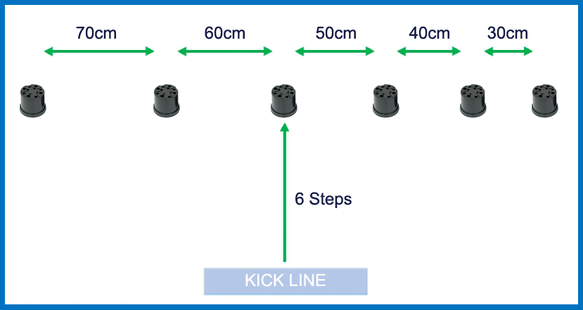
- 1 point per gap kicked between.
- No points if you kick the ball through another gap, not aimed for.

- High Score: Best score from two full turns (10 kicks in total).

Variations:
- Change the distance between the kick line and the plant pot gaps.
- Change the gap sizes. To make the game easier, start with 1m to 60cms gaps.
- Change the order of narrowing gaps from left to right, to right to left. Or randomise where the smaller gaps are in the line.
- 2 Round Challenge: Continue the next round from where you left off in the previous round. If you scored 3 points in the first round, continue aiming for the 4th gap (40cm’s) at the start of the next game. Scoring: How many kicks it takes to complete 2 full rounds?
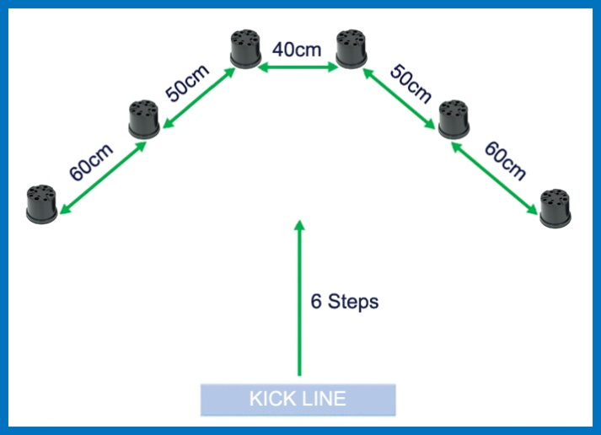
- Push Ball: Place another (similar sized) ball in front of the gap you are aiming for. Hit this ball, with your football, to knock it through the gap. How many attempts needed to hit & push a ball through all the gaps, without knocking over the plant pots?

- Pyramids: Move the plant pots into a pyramid (or tree) shape. Play for the sides first, then aim for the central 40cm gap on your last attempt.

- Pyramids - Competitive Game: With a family member. Pick a side. Alternate kicks. Aim for outside (60cm) gap first, then 50cm gap. Winner is the first through the 40cm gap.

Murray Movement
Video Link - https://youtu.be/7pmANg7YV6Q
Equipment:
- Bean bag (small ball, rolled up socks, gloves folded into themselves, small wooden block)
- Racket (trowel, hardback book, serving spoon)
- 17 x Plant Pots (household items: plastic bottles, tins)
- Stopwatch

Set up: See diagram. Each grid square is one step x one step. The plant pots are ‘gates’ to run through and one needs to be run around.
Aim: “To complete the slalom whilst balancing a beanbag on a racket”
- If you drop the bag, replace it on the racket and continue.

Scoring:
- Timed: Time taken to complete the course.

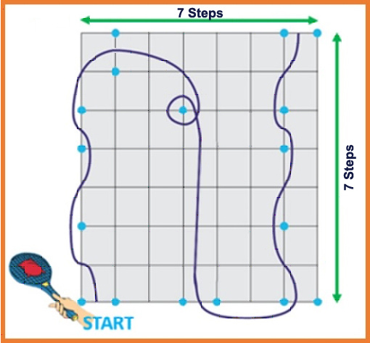

Variations:
- The tennis ball bouncing on the racket whilst completing slalom.
- ‘There & Back Again’ version: Start from the line to complete the course then turn round at the finish line to head back to the original start line.
- Equipment can be changed for example using a football to dribble around or a hockey stick and ball.
- Enlarge the course. Each grid square is two steps (Total space: 14 x 14 steps).
- Try placing the bean bag on their head & running through! Faster or slower?

Adaptations:
- Wheelchair users: Self-propel on a wider course or be pushed.
- If you have balance difficulties, involve the support from an adult and walk through the course. You may carry the beanbag without a racket, if needed.

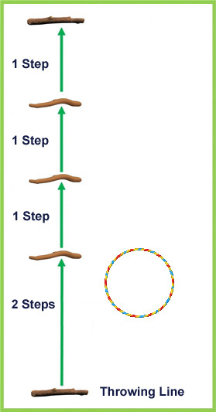
Flip it
Video Link – https://youtu.be/pa-xZU71H2E
Equipment:
- Small Ball
- Hoop (bicycle tire, bucket, newspaper)
- 5 x Sticks (plant pots, rope, string)
- Kitchen Timer (stopwatch)
Set Up: Use a stick as a throwing line then place a stick two steps away followed by a stick a further step away until all five sticks are placed.

Use the sticks as distance markers, they are not lines to run over.
Aim “Land the ball in the hoop”
- 4 throws per turn, all thrown from behind the throwing line.
- Start each turn aiming at the hoop, placed at the 2 step line.
- Score from where the ball first lands. It can roll out.
- If successful move the hoop onto the next stick line, progressing up one step line at a time.
- Do not move the hoop on a miss.

Scoring:
- 1 point per ‘flip’ (maximum of 4 points per turn).
- 1 bonus point, if you score 4 points in a row (4 consecutive flips).
- Timed: Total points based on 60 seconds of play. You will need to collect your ball & move your own hoop.
- Best Score: How many points from 3 turns? (12 throws)

Variations Games:
- Up and down the ladder. Hoop progression: Start the hoop at stick line 1, work up to stick line 4, and then back down to stick line 1 position. (1-2-3-4-3-2-1).
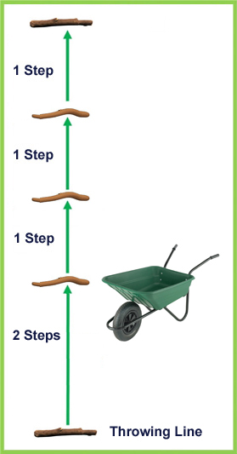
- Barrow Run – Use a wheelbarrow as a target instead of a hoop. Wheel the barrow on to the next line after each successful throw.

Loopy: Basketball Bounce & Shoot
Video Link – To come, in future update of this document
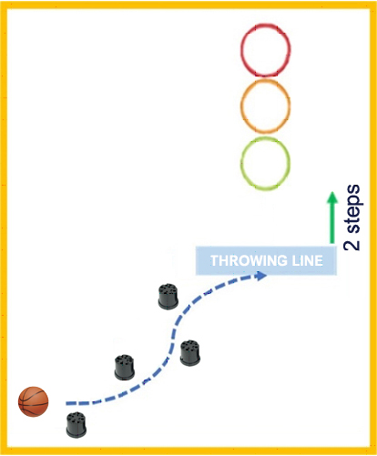
Equipment:
- Medium sized ball: basketball, football
- 3 x Hoops (newspapers, cardboard, buckets, boxes)
- Many x Empty Plant Pots (plastic bottles)
- Kitchen Timer (stopwatch)

Set-up: Set up two areas:
A ‘slalom course’ to dribble the ball through - use the outdoor space available. Be inventive with the course.
A ‘throwing area’ with 3 targets, the closest target placed two steps away.

Aim: “Players dribble through the slalom course and arrive at the throwing line, from which they shoot for a hoop”
- Players basketball dribble (or bounce catch) from the start, through the slalom course.
- Players need to bounce the ball at least 3 times before shooting from the throwing line.
- They have one attempt to shoot from the throwing line aiming at any hoop. Players then collect their ball and return to the start for attempt two.

Scoring:
- Points are scored in the hoop in which the ball first bounces (it can hit the rim of the hoop).
- The throw lands in the:
  - First hoop = 1 point
  - Second hoop = 2 points
  - Third hoop = 3 points

- High Score: Best score from three rounds.
- Timed: Best score from 60 seconds of play.

Variations:
- Wheelchair users can carry the ball on their lap. If possible, bounce the ball at least once, before reaching the throwing line.
- Practice different ways of dribbling – one handed dominant hand, one handed non-dominant hand, alternate hands, dribble at different heights.
- 1-2-3 Hoops: In first round, aim for the first hoop only. In the second round, aim for the second hoop only. In the third round, aim for the third hoop only.
- Practice dribbling drills as a warm-up: How many bounces can you complete in 30 seconds, stationary? Then running?

- Rackets: Balance a tennis ball on a racket through the slalom section, then volley the ball into the hoops.
- Football: Dribble with your feet through the slalom section, then take a throw-in at the hoops.

Rally Tennis

Video Link – To come, in future update of this document
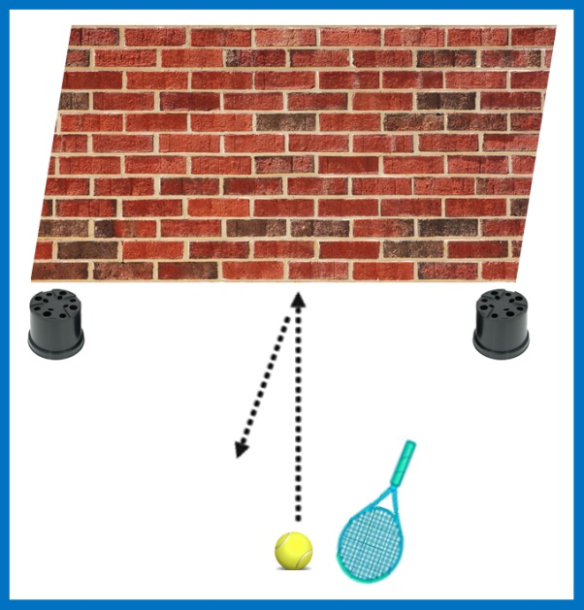
Equipment:
- Tennis Soft Ball (small ball)
- Racket
- Wall
- 2 x empty Plant Pots (cones, plastic bottles)
- Kitchen Timer (stopwatch)

Set-up: Place 2 plant pots two or three steps from each other, next to a flat wall, with no windows above.

Aim: “Rally a ball against a wall”
- Hit the ball against a wall, in an area between two plant pots. Continually move to play the shots.
- The ball can roll on the floor, bounce (once or many times) or be hit on the volley.
- The rally finishes when the ball is not returned to the wall between the two plant pots.
- Initially we recommend player’s starting position is approximately three steps from the wall.

Scoring:
- Timed/High Rally: The longest rally recorded within 30 seconds.
- Timed: The number of hits on the wall in 30 seconds (may be across multiple rallies).
- High Rally: The longest rally recorded regardless of time.

Variations:
- Wheelchair users can use their chair to stop the ball, this does not affect rally count (side-on using the big wheel).
- Increase the time to 45 seconds or 1 minute.
- Try different shots - volley only, forehand or backhand only. Restrict yourself to a volley or just one bounce.

Starter Variations:
- If playing with a racket is difficult, start with a catching and throwing game:

- Solo Catching: How many catches from one hand to other (continuously alternating hands) can you complete in 30 seconds? To make easier, change the ball to a balloon.
- Catch with another: Throw catches to each other. Progress to one bounce & catch. Add a target area for the bounce (hoop or chalked area), and gradually move away from each other.
- Catch off the wall (no racket): How many rebound catches in 30 seconds. Using both hands. Using just one hand (to throw and to catch). Or, throw with one hand & catch with the other.

- To introduce ball control on a racket:
  - Balance: Balance the ball on a racket for a set time. Stationary/walking/running.
  - Balance Circles: Circulate the ball around the racket ridge. How many circles can you complete?
  - Keep Ups: Number of bounces on a racket in 30 seconds. If the ball drops to the floor, pick it up and continue.
  - Knock Downs: Bounce the ball against the floor using the racket.

- Cup in the Hand Game:
- Additional Equipment: Paper Cup, Small Ball (Table Tennis ball sized)
- Throw a small ball in the air and catch it in a paper cup. Can you do 5 in a row? To make more difficult, add rule: the ball needs to be throw the ball in the air above your eye line to count.
- Throw the ball against the wall and catch it with the paper cup. Can you do 5 in a row?
3-2-1 Buckets variation game:

Video Link – To come, in future update of this document
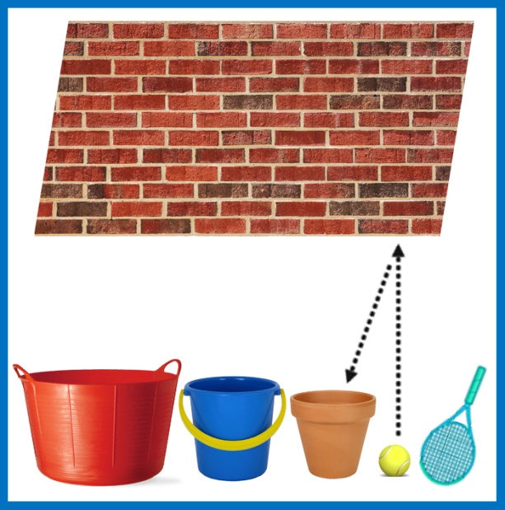
Additional Equipment:
- 3 x empty Plant Pots or Buckets
- 9 x counters (coins, stones)

Set-up: Place the buckets one step away from the wall in a row. Place three counters in each bucket.

Aim: “Hit a ball to rebound from the wall into a bucket”
- Standing to the side of the buckets. Use a racket to hit the ball.
- When a ball lands and stays in a bucket, take 1 counter out of that bucket.
- When a bucket has lost all its counters, turn over that bucket.
- Continue until all the buckets are turned over.

Scoring:
- High Score: How many strikes does it take to turn over all the buckets?
- High Score: How many strikes does it take to turn over all the buckets, in order?
First, aim for the left bucket only. Once that bucket is turned over, aim for the middle bucket only. Don’t collect the counter if you land the ball in the wrong bucket. Continue until the three buckets are turned over.
- Timed: How many times can you land a ball in the buckets, in 1 minute?

Variations:
- No Wall: To get the hang of the game. Aim for bucket without using the wall – try 2 paces away, then move closer or further away.
- Change the distances of the buckets from the wall.
- Change the position where you hit the ball, forwards or backwards from the buckets, from a side angle, or, only hit from one set position.

- Traffic Lights visuals – Same game but using coloured buckets (if you have them): Red (Terracotta), yellow and green. Turn the traffic lights on in sequence - red, to yellow to green.
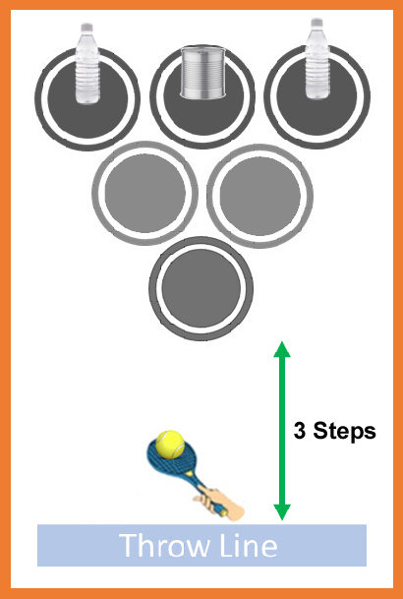
Venus Volley variation:

Video Link – To come, in future update of this document

Additional Equipment:
- 3 more Plant Pots or Buckets
- 3 x Household Items: Plastic Bottles, Tins, Hats.
Set-up: As per diagram. Triangle of buckets, 3 steps from throw line. Turn the buckets upside down. Add 1 item on top of the furthest 3 buckets.

Aim: “Using a racket, propel a ball towards buckets to score.”
- 6 hits per turn. Technique: rest the ball on racket & push out.

Scoring:
- Ball hits a bucket = 1 point.
- Ball hits any of the 3 items on the furthest buckets = 3 points.
- If the items fall off the buckets, replace only at the end of each turn.
- High Score: Highest points from one turn (6 hits)?
Athletics - Jumping
Video Link – To come, in future update of this document
Equipment:
- Tape Measure
- Marker (cloth, glove)

Set-up: Choose a suitable jumping area. Wear suitable non-slip shoes/trainers.

Aim: “Jumping for distance”
- Stationary start for all jumps (no run ups).Two footed take off. Have both feet behind a take-off line.
- Hold the marker in your hand to measure your jumps. If you are on your own, measure the distance from where the front of your foot first lands.

Jump sequence variations:
- One / three / five hops (using your left foot only)
- One / three / five hops (using your right foot)
- Three / five steps (step from one foot to the other)
- Standing triple jump (one hop, one step followed by a jump landing on two feet)
- Wheelchair users can record a distance from one push with both hands.

Scoring:
- Longest Jump: Measure best jumps. Which combinations of jumps are easier and those more difficult for you?

Jumping Game: Treasure Chest
Extra Equipment:
- 4 x household items (that can be easily carried)
- Kitchen Timer (stopwatch)
Set-up: Place the four items a distance (use the space you have) away from a start line. By the start line, have a collection area where items can be placed when retrieved.

Aim: “Timed step sequence to collect treasure”
- 4 laps to collect all the items (treasure).
- Bring back item at a time and place in the collection area.
  - 1st Lap - 1 footed hop. Collect item. Run back.
  - 2nd Lap - Two footed hops. Collect Item. Run back.
  - 3rd Lap - Run & Jump of the rhythm 1step – 2step – 3step - Jump, 1-2-3-Jump. Collect Item. Run back.
  - 4th Lap - Side Steps. Can also lift arms. Collect Item. Run back.
- For Wheelchair users – 1 hand (left), 1 hand (right), Both hands with 1 x 360 degree turn in the middle, Backwards/or slalom with 2 cones (one on side left, one on side right).

Scoring:
- Timed: How long does it take to collect all four items?

Variations:
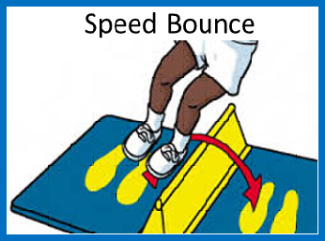
- Correct Combination: Player brings back the items in a particular order eg colour code the items. lap 1 = red item lap 2 = green item etc.
- Think about different forms of movement to collect the items. Other running variations could include – crawling fast on all fours, ‘in a potato sack’ jumping, 1-2-3-Forward Roll, Skipping etc,
- Speedbounce: How many 2 footed jumps from side to side can you do in 10 seconds? Can use a glove to jump over, but don’t land on it!
Panathlon at Home - Multi-Skills Scores
My Name: ______________________________

Game: | Best Scores/Times | Best Scores/Times | Best Scores/Times

Email: events@panathlon.com Twitter/Instagram/Facebook: @panathlon #PanathlonGardenGames

