Functional Skills English

Entry Level 1 Work Booklet

Name:

Topic 1

Alphabet - Upper and Lowercase Letters

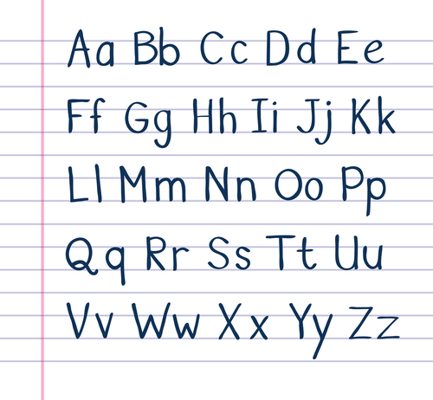

Draw a line to match the lowercase letters of the alphabet to the UPPERCASE letters of the alphabet.
Uppercase is one of the large letters used as the first letter in writing a sentence, usually known as capital letters.
A lowercase letter is the small version; a, b, c,
A |  | d
B |  | m
C |  | b
D |  | i
E |  | p
F |  | a
G |  | l
H |  | j
I |  | o
J |  | g
K |  | k
L |  | e
M |  | n
N |  | c
O |  | f
P |  | h

Fill in the next letter of the alphabet:
- S T U V ___
- e f g h ___
- L M N O ___
- q r s t ___
- B C D E ___

Write the letters in lowercase:
- A B C D ________________________________
- H I J K ________________________________
- O P Q R ________________________________
- W X Y Z ________________________________
- D E F G ________________________________

Write the letters in uppercase:
- j k l m ________________________________
- p q r s ________________________________
- c d e f ________________________________
- g h i j ________________________________
- n o p q ________________________________

Put these letters into alphabetical order:
- g s h t ________________________________
- o l i j ________________________________
- d c b a ________________________________
- z x w y ________________________________
- n k l m ________________________________
Fill in the missing letters

A |  | C |  | E
F |  | H |  | J
K |  | M |  | O
P |  | R |  | T
U |  | W |  | Y
Z

Topic 2

Using Capital Letters

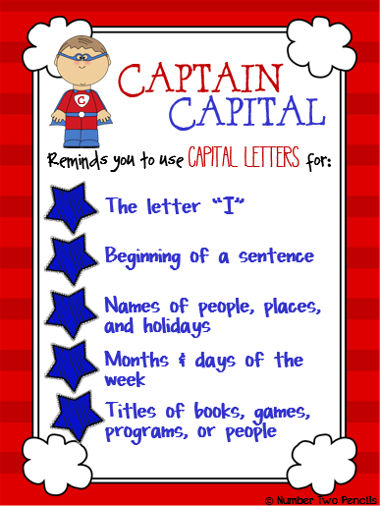
Recognise that proper nouns always have a capital letter. Proper nouns are names of people.
Write down five of your friend’s names in the box.

Proper nouns are names of places.
Write down five places you have visited.

Proper nouns are days of the week and months of the year.
Write down the month you were born and what day it is today.

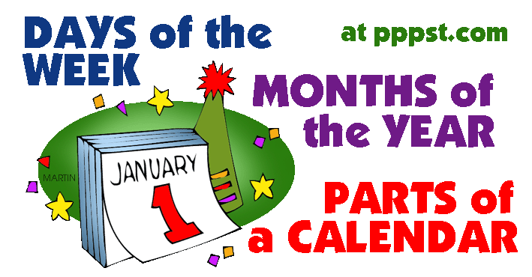

Capital letters are also used for people’s names, towns, street names and days of the week.

Look at this story and circle the letters that you think needs to be a capital letter.

on monday stephen and edward were taking their pet dogs, tilly and molly, for a walk. they walked down rooney avenue and as they entered the field a strange dog ran up to them. they were not sure what to do as it looked very thin and hungry. it just stood there looking sad, so they decided to take it to their mum. she said they would look after it and they put posters up in manchester, the city where they lived.

after a couple of days a woman called at their house. Her name was mrs walker. she was very happy that they had found her dog, whose name was ben. she gave stephen and edward twenty pounds each to say thank you.

A friend has written a letter. They have asked you for help. Can you find all the places they need to use a capital letter?
Circle each one -
3 Lindale Close
Addington
Ad16 3ty
Tuesday 2nd November, 2014
dear Ann,

thank you for dinner on Sunday. we hope you can come and see us when you visit Scotland in December. if you come after Christmas, i think Michelle will be here too. she would love to catch up with you before she goes back to Bolton. I hope I get a chance to speak to you on Saturday.

best wishes,

sam and lisa

Please rewrite these sentences with the correct capital letters.
are you going to manchester today?
_______________________________________
what time is it tom?
_______________________________________
i have been to france and spain.
_______________________________________
where is lisa, we should be at the disco?
_______________________________________
mrs walker talked to the boys.
_______________________________________
i like to go shopping in middlesbrough.
_______________________________________
my favourite food is pizza.
___________________________________
i like watching television.
_______________________________________
i am going on holiday to benidorm.
___________________________________
my favourite film is frozen.
_______________________________________

Put a tick in each box that you think should begin with a capital letter.
monday | sunday | spain | man
bolton | tree | apple | spring
tom | nice | autumn | middlesbrough
little | dog | city | manchester
may | rome | wednesday | peggy
town | pizza | garden | liverpool
january | gemma | summer | mother
france | father | december | country

Topic 4

Punctuation

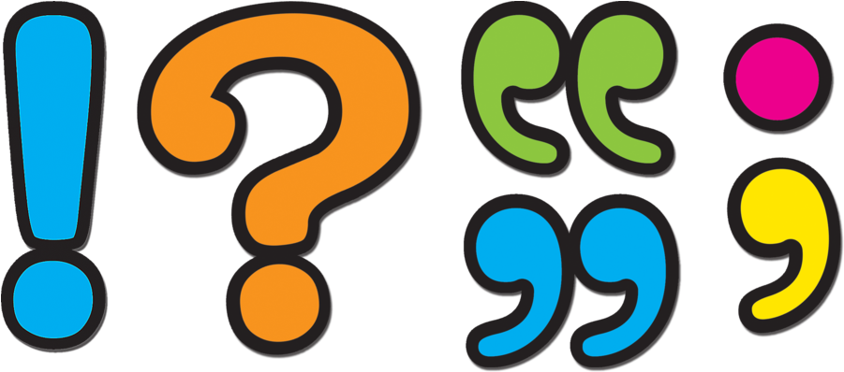

Punctuation – What does it mean?

Below are some meanings of punctuation to help you with your writing.
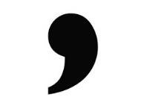
Comma
Commas are used when the reader needs to take a pause or when writing a list. E.g. I went to the shop for eggs, butter, milk and bread.
Full Stop

A full stop is used to show the end of a sentence. E.g. She went to the bank to get some money out.
Question Mark

This is used when asking a question. E.g. What time does this lesson finish?
Exclamation Mark

These are used to show commands, shock or surprise. E.g. Wow he is a really good singer!

Punctuation Match
Match the correct definition to the correct punctuation mark. The first one is done for you.

Capital Letter Used to separate a list of items. A natural pause in speech.

Full Stop . Used at the end of a command or exclamation to show feelings such as surprise, shock and excitement.

Exclamation Mark ! Used at the beginning of a sentence and also: names, places, the word I, days of the week and months.

Comma , Used to show the end of a sentence.

Question Mark ? Used to show a question.

Spot the errors.
Use a coloured pen or pencil to correct the mistakes:
It had been a glorious day. Everything had gone as planned
the bride looked lovely and no one had kicked off sandra
breathed a sigh of relief. she had been so worried! She had
told everyone that careful planning would safe the day and
she had been right. If only people would listen to her more

maggie was unhappy. She had tried her best all day. But
nothing had gone well it was like the world was against her.
“why does it always happen to me?” she cried

once upon a time there lived a small dog he liked to eat things that he should not
one day he came across a story and ate all the full stops and capital letters
you came to the rescue and saved the day and fixed all of the mistakes

Topic 5

Spelling

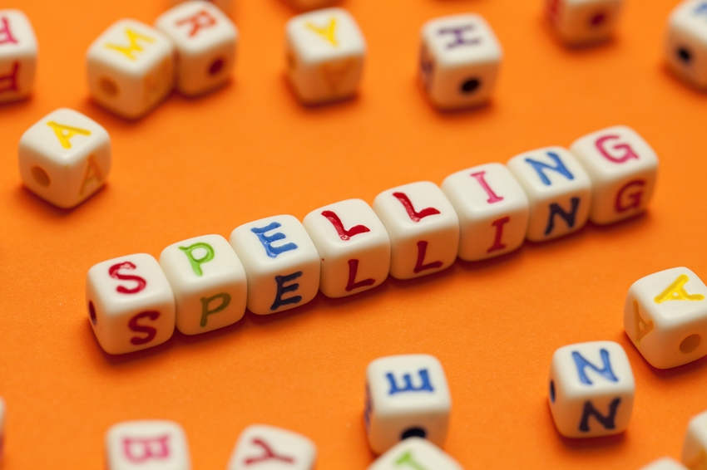

Choose the correct word to complete each sentence.
Write the word in the gap.
The first one has been done for you.
Example: What’s his name?
his
hiss
hiz

  - I work every .........................................................................
Saterday Sataday Saturday
his
hiss
hiz

  - I want to .............................................................................. in that shop.
look luk looke

  - Come .............................................................................. please.
hier here heer

  - Why didn’t you say …………………………………………………………… ?

  - Sam plays football every …………………………………………………
week wiek weeck
hier here heer

helo hellou hello
hier here heer

(f) I get the bus .............................................................................. town.
intoo intwo into

(g) It was the best year of my ....................................................
lyfe
life laife

(h) The cafe is .............................................................................. now.
opan oppen open

(i) It was a lovely sunny ..............................................................
dei day dey

(j) Mia .............................................................................. to go home.
wanted wonted wantted

(K) This .............................................................................. I turn eighteen.
yur
yerr
year

Topic 6

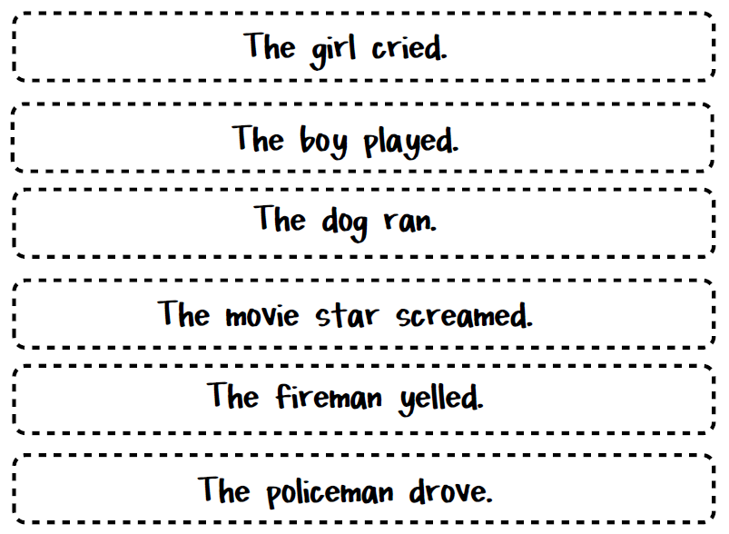
Writing Sentences

A sentence is a group of words that are put together to mean something.

Sentences
he | she | we | me
was | my | you | her
all | our | be | they

Write some sentences using these words. Don’t forget to put a full stop at the end of your sentence!
___________________________________________________________________________________________________________________________________________________________________________________________________________________________________________________________________________________________________________________________
_________________________________________________________________________________________________________
Sentences
think | money | take | plant
head | girl | fast | Saturday
ask | could | late | walk

Write some sentences using these words. Don’t forget to put a full stop at the end of your sentence!
___________________________________________________________________________________________________________________________________________________________________________________________________________________________________________________________________________________________________________________________
________________________________________________________________________________________________________
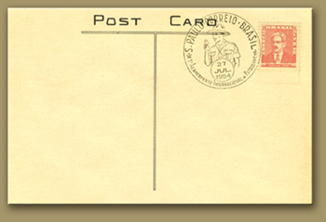
You are on your holidays. Write to a friend on a postcard and tell them:
- Where you are
- What you are doing
- What 2 things you like about your holiday

Dear __________________  _____________________  _____________________  _____________________  _____________________  _____________________  _____________________  _____________________  _____________________  _____________________  _____________________  _____________________  _____________________ | 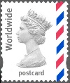  Mr Joe Bloggs  1 Cannon Street  Ribchester  England  RK1 6HG
You want to go to a cafe for lunch.
Write a note to ask your friend to come with you.
Write in sentences to tell your friend:
- what day and time you want to go
- two things you want to eat or drink
- two things you want to do after lunch.
Use capital letters and full stops where you need to.
_______________________________________________________________________________________________________________________________________________________________________________________________________________________________________________________________________________________________________________________________________________________________________________________________________________________________________________________________________________________________________________________________________________________________________________________________________________________________________________________________________________________

You shop at a new supermarket. Fill in this feedback form to say what you think about it.
Write in sentences to say:
- two things you like about the supermarket
- two things you don’t like about the supermarket.
Use capital letters and full stops where you need to.
Supermarket Feedback Form
Things I like about the supermarket

__________________________________________________________________________________________________________________________________________________________________________________________________________________________________________________________
Things I don’t like about the supermarket

__________________________________________________________________________________________________________________________________________________________________________________________________________________________________________________________

Topic 7

Reading

Reading - Read the text and answer the questions.

What is on TV at 7.30pm on BBC 1? _________________________________
Holby City is on Channel 5, True or False? ____________________________
What is on ITV 1 at 8.00pm? ______________________________________
What time is World’s on? ________________________________________
Can you watch Ultimate Bikers on BBC 1? _____________________________
Is Sherlock on Channel 4? ________________________________________
What time is Restoration Man on and what channel? _____________________
Coronation Street is on Channel 4, True or False? ______________________
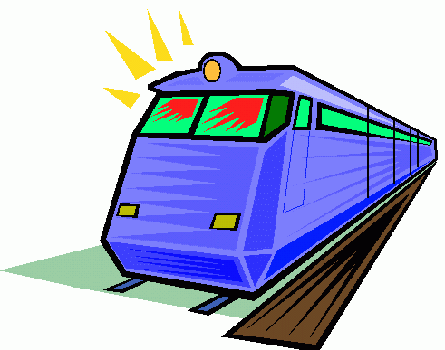
Reading

Amanda lives in Newcastle and goes to London to see her sister. She goes by train. At the station she buys a return ticket. It takes 3 hours from Newcastle to London.
Answer these questions about the story above, and circle the one you think is right:

1) Why does Amanda go to London?
a) To see her brother
b) To see her sister
c) To see her friend

2) How does Amanda travel to London?
a) By bus
b) By car
c) By train

3) How many hours is it to London?
a) 1 hour
b) 2 hours
c) 3 hours

- When did Deepak start his new job?
.................................................................................................................................

- What day does he work from 9 am to 5 pm?
.................................................................................................................................

- What did Mrs Woods make for Deepak on his first morning?

- Where is the cafe?
.................................................................................................................................

- How long does it take to walk to the cafe?
.................................................................................................................................

again  air  all  also  any  anyone  are | around  as  ask  can  change  children  close | come  could  cross  day  dear  do  does | few  find  first  floor  follow  for  four | Friday  full  get  girl  here  high  his | hold  house  how  into  is  know
Morning  Most  My  Myself  Near  Never  New  No  Now  Number  Of  Off | Push  Real  Reply  Right  Room  Said  Same  Saturday  Saw  Says  There  They | Think  Thursday  Time  To  Today  Together  Told  Too  Tuesday  Where  Which  While | White  Who  Will  Without  Word  Work  World  Would  Write

