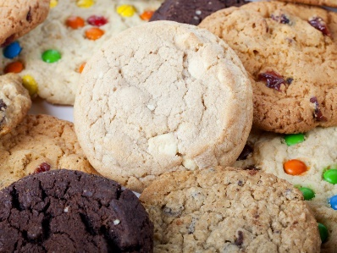
G8/G9 Biscuits

Ingredients.
- Plain flour 75g
- Caster sugar 25g
- Butter 50g
- Choose from chocolate chips, raisins, vanilla drops, cherries, dried fruit, cinnamon, cocoa powder to make different flavours.
Equipment
- Bowl
- Baking tray
- Cooling rack
- Food bags (if using for ingredients).
Method
- Prepare ingredients into different food bags or bowls (1 each for ingredient). Some students can work towards measuring but for most students the focus is on the process.
- Wash hands thoroughly. The students will be good at this by now!
- One at a time empty the bags/bowls into a large bowl.
- Rub ingredients together.
- Mix in any additional ingredients eg chocolate chips.
- Squeeze together to make a dough.
- Roll into balls
- Put on baking tray and squash down.
- Put into oven to bake for approx. 15 minutes. 170/325/gas mark 3.

Further notes on the other side.
For some students this will be a sensory cooking activity and the ingredients may not make it to the oven! This is fine.
Encourage collecting and carrying resources, washing up and putting away.
There is enough to make approx. 6 biscuits. The idea is that they repeat it not that there is one big batch. Introduce choices and as they become more familiar with the activity reduce support as appropriate.
Hopefully there will be some biscuits for you to enjoy at the end with a well-earned break.
Please send in any photographs to show either the sensory experience, any finished biscuits, independence skills – collecting, tidying up(this will probably take the most time), making or the fun part the eating!
Happy cooking!

